CIRCUIT ANALYSIS LAB_2
Name: Muhammad Uzair
Reg No: 2025-CE-112
Date: 16thMarch,2026

Experiment # 1:
SIGNAL GENERATOR AND OSCILLOSCOPE:
1. Use the signal generator and the oscilloscope to perform the following tasks.
2. Build circuit shown below in Figure.
3. Set the signal generator to generate a sinusoidal signal with a frequency of 100 Hz and peak-to
peak voltage of 5V.
4. Set up one probe across input signal, and another across R1 and R2 alternatively.
5. Measure and draw all the voltages and time related parameters on the graphs below.

Circuit Made In Proteus:
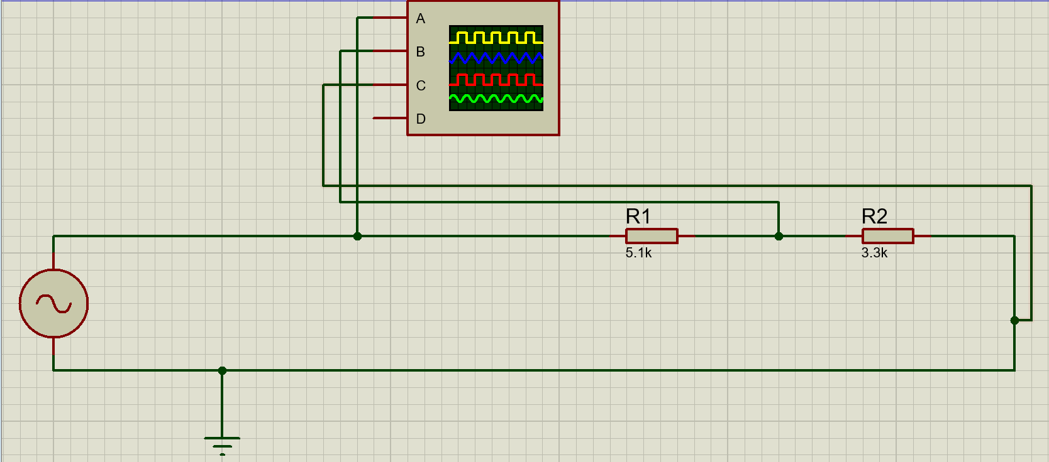
TABLE FOR READINGS:
Resistor | Input Voltage | RMS Voltage | P-P Voltage
R1 | 5V | 1.073V | 3.036V
R2 | 5V | 0.694V | 1.964V

Graph for Input Voltage Signal(5V):
One Vertical Box = 1V
One Horizontal Box = 1milli-second
One Complete Wave in 10 boxes
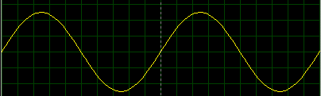

Graph for Voltage Across R1:
One Vertical Box = 1V
One Horizontal Box = 1milli-second
One Complete Wave in 10 boxes
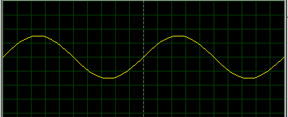
Graph for Voltage Across R2:
One Vertical Box = 1V
One Horizontal Box = 1milli-second
One Complete Wave in 10 boxes
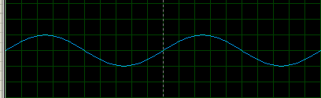

Graph for Input Voltage 7V:
One Vertical Box = 1V
One Horizontal Box = 1milli-second
One Complete Wave in 10 boxes
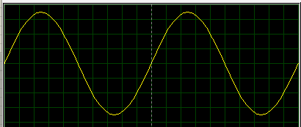

Experiment # 2:
SIGNAL GENERATOR AND OSCILLOSCOPE
1. Use the signal generator and the oscilloscope to perform the following tasks.
2. Build circuit as shown below in Figure.
3. Set the signal generator to generate a sinusoidal signal with a frequency of 200 Hz and peak-to
peak voltage of 7V.
4. Set up one probe across input signal, and another across R1, R2 and R3 alternatively.
5. Measure and draw all the voltages and time related parameters on the graphs below.

Circuit Made In Proteus:
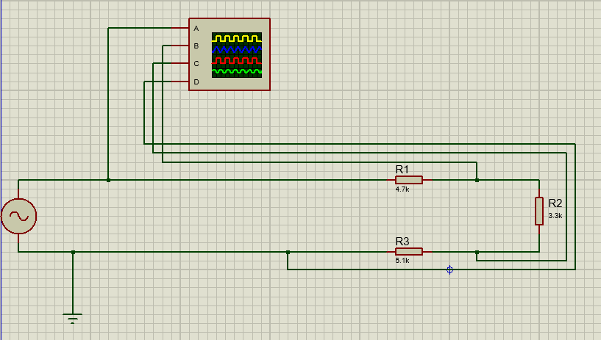

TABLE FOR READINGS:
Resistor | Input Voltage | RMS Voltage | P-P Voltage
R1 | 7V | 0.89V | 2.51V
R2 | 7V | 0.62V | 1.76V
R3 | 7V | 0.96V | 2.73V
R1 and R2 | 7V | 1.51V | 4.27V
R2 and R3 | 7V | 1.59V | 4.49V
Graph for Input Voltage(7V):
One Vertical Box = 1V
One Horizontal Box = 1milli-second
One Complete Wave in 5 boxes
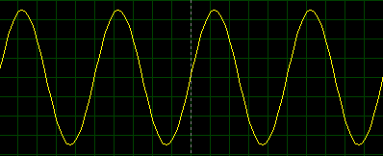
Graph for Voltage Across R1:
One Vertical Box = 1V
One Horizontal Box = 1milli-second
One Complete Wave in 5 boxes
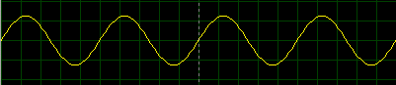
Graph for Voltage Across R2:
One Vertical Box = 1V
One Horizontal Box = 1milli-second
One Complete Wave in 5 boxes
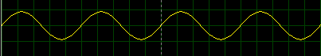

Graph for Voltage Across R3:
One Vertical Box = 1V
One Horizontal Box = 1milli-second
One Complete Wave in 5 boxes
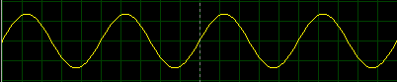

Graph for Voltage Across R1 and R2:
One Vertical Box = 1V
One Horizontal Box = 1milli-second
One Complete Wave in 5 boxes
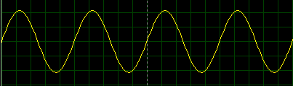

Graph for Voltage Across R2 and R3:
One Vertical Box = 1V
One Horizontal Box = 1milli-second
One Complete Wave in 5 boxes
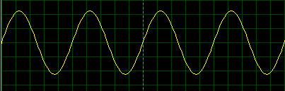

POST LAB QUESTIONS & ANSWERS:

1. Define Ohm's Law.

Ans: Ohm's Law states that the current flowing through a conductor is directly proportional to the voltage across it and inversely proportional to its resistance: V = IR, where V is voltage (volts), I is current (amperes), and R is resistance (ohms).

2. What is a resistor?

Ans: A resistor is a passive two-terminal electrical component that opposes the flow of current in a circuit. It is used to control current, divide voltage, and protect other components by dissipating energy as heat.

3. How does a resistor work?

Ans: A resistor works by limiting current flow through its internal material, which has a fixed opposition to electron movement. When current passes through it, electrical energy is converted into heat. The amount of resistance (measured in ohms) determines how much current is restricted.

4. What is your inference from the input and output waveforms on the oscilloscope?

Ans: The input and output waveforms confirm that the resistor does not alter the shape or frequency of the signal — only the amplitude (voltage) may differ. This verifies Ohm's Law in action, showing a linear relationship between voltage and current with no phase shift introduced by a purely resistive component.

5. Show calculations of 7V input signal (Figure Experiment 2) from signal generator.
a. Voltage Calculations:
Total V_{p-p}: 7V
Volts/Div setting: 1V/div
Number of boxes (vertical): Since V_{p-p} is 7V, the signal will span 7 vertical divisions (from -3.5 to +3.5).

b. Frequency/Period calculations:
Frequency (f): 200 Hz
Period (T): T = 1/200 = 5ms
Time/Div setting: 1ms/div
Number of boxes (horizontal): 5ms/div, 1ms/div = 5 divisions for one full cycle.

c. Current calculation (Ohm’s Law):
Total Resistance (R_{T}): 13.1kΩ
Using Ohm's Law for peak current (I_{p}):
V_{p} = V_{p-p} / (2) = (7V) / (2) = 3.5V
I_{p} = (V_{p})/(R_{T}) = (3.5V) (13,100Ω) ≈ 0.267mA

